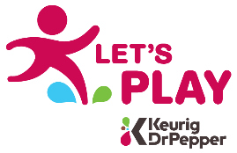
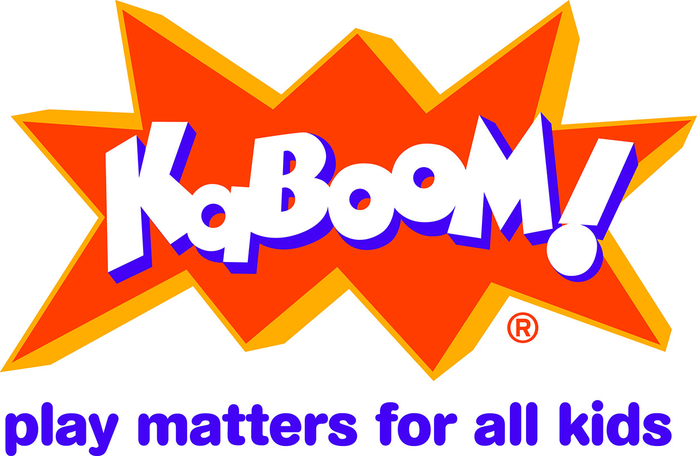

FOR IMMEDIATE RELEASE

CONTACT:
Mullica Township, Dawn Stollenwerk 609-561-7070, dstollenwerk@mullicatownship.org
KaBOOM!: Tamara Grider, 202-464-6196, tgrider@kaboom.org

Keurig Dr Pepper and KaBOOM! Award Mullica Township a Let’s Play Construction Grant

Elwood, NJ 2/1/2020 – Keurig Dr Pepper (KDP) and the national non-profit KaBOOM! awarded Mullica Township a Let’s Play Community Construction Grant that will be used to complete Phase II of its PineCone Zone Playground Revitalization Project.
The playground build is made possible by Let’s Play, an initiative by KDP to provide the funding, equipment and play spaces to help kids and families make active play a daily priority. Through Let’s Play, KDP and its partners are committed to helping create safe and inspiring PLAYces for Mulica’s kids to learn, explore, grow and just be kids.
“We are thrilled to be awarded this grant,” said Kristi Hanselmann. “We couldn’t have considered completing our project so quickly without the support of Keurig Dr Pepper and KaBOOM!”
The Township and Recreation Association are partnering to use the grant to complete Phase II of its playground project, installing equipment for children ages 5-12. The Township has been working the last few years to develop a comprehensive plan to replace the existing PineCone Zone Playground, built over 20 years ago by community volunteers. The PineCone Zone is the only public playground in Mullica, and the Township is excited to continue the project started in October of 2019.
KDP has committed $38.5 million to Let’s Play through 2019, impacting youth-serving organizations across the U.S., as well as Canada, Mexico and the Caribbean. Through Let’s Play, KDP partners with two non-profit organizations, KaBOOM! and Good Sports, to build and improve playgrounds in underserved communities and provide grants for sports equipment. In this way, KDP is doing its part to help eliminate the play deficit by making active play possible for more kids.
Visit Let’s Play at www.LetsPlay.com to join the conversation and learn how to apply for the various available grants to make communities more active and playful.
###
About Mullica Township Recreation:
The mission of the Mullica Township Recreation Association is to support and promote the development and preservation of recreation, wellness, parks, and natural resources for all residents of Mullica through partnerships with the community and the Municipality.

About Let’s Play
Let’s Play is an initiative by Keurig Dr Pepper to provide the funding, equipment and play spaces to help kids and families make active play a daily priority. KDP partners with KaBOOM! to build and improve playgrounds and with Good Sports to provide sports equipment grants to kids that would otherwise not have access. Let’s Play has already provided more than 11 million kids new opportunities to play. With year-round grants available for new or improved playgrounds and sports equipment, Let’s Play helps kids achieve balanced, well-rounded lifestyles. For more information, please visit LetsPlay.com or Facebook.com/LetsPlay.

About KaBOOM!
KaBOOM! is the national non-profit dedicated to giving all kids – especially those living in poverty – the childhood they deserve through great, safe places to play. KaBOOM! inspires communities to make play the easy choice and works to drive the national discussion about the importance of PLAYces. KaBOOM! has collaborated with partners to build or improve more than 17,000 playspaces, engaged more than 1.5 million volunteers and served over 10 million kids. To learn why play matters for all kids, visit kaboom.org and join the conversation at twitter.com/kaboom, facebook.com/kaboom and instagram.com/kaboom. #playmatters #PLAYceforKids

